Corporate Fundraising
Whatever the size of your company or the level of support you are able to offer, we want to hear from you. From raising money for research projects, vital equipment, and essential facilities, you can help us transform lives.
Why fundraise for The RNOH Charity?
As well as boosting staff morale and being a great exercise in team building, there are numerous benefits to supporting us.
- Media recognition:
If your company raises a significant amount of money for The RNOH Charity, we’ll make sure everyone knows about it! From local press, to being featured on our social media, fundraising for us is a great way to increase your visibility while contributing to a great cause. Hunter Healthcare volunteered their time in 2016 and had this to say about their experience:
“We had a fantastic day as well as helping the hospital – it was really good for us to do some team bonding.” Phoebe Webb, Head of Operations and Performance
- Taking on an exciting challenge:
From skydives to the Superhero run, we have lots of challenges for your team to get involved in. Ink Global took on a gruelling trek through the Sahara desert to help our 2016 crowdfunding campaign to expand our world-renowned Spinal Cord Injury Centre. After two days of blistering heat and sand, they had succeeded in completing their challenge and raising £10,000 for the charity:
“I am proud (and sore) to have helped lead (and be led) through that desert by a dedicated and driven bunch of colleagues. We are proud to be fundraising for the Royal National Orthopaedic Hospital Charity's ‘Make It Possible Campaign’, and we hope to see them raise enough money to expand their Spinal Cord Injury Centre (SCIC) to help people with spinal injuries get the specialist help they need.” Simon Leslie, Joint CEO
- See the difference you’ve made:
If you raise a significant amount for a vital piece of equipment, or to fund a ward in our new hospital, you will be able to see first-hand the difference how your money has been invested at a launch event, or unveiling. An example of this is the London Irish Ward Appeal, launched by Kelly Communications in June 2016 to raise a staggering £500,000 to fund a new adult acute ward, which will be named in acknowledgement of the London Irish community. You can read more about their Appeal here.
Ways to get involved:
Staff fundraising
A fundraising event organised by your staff is a great team-building exercise, and has a positive impact on employees’ motivation and confidence. You can organise anything, from an inter-departmental tournament, to a team abseil. Or if your team is particularly adventurous, you could even organise a trip to climb Kilimanjaro! Cake sales are popular for good reason – no one can resist the call of freshly baked treats. We’d love to help you come up with a unique event that really represents your team so please contact us to discuss any ideas you may have.
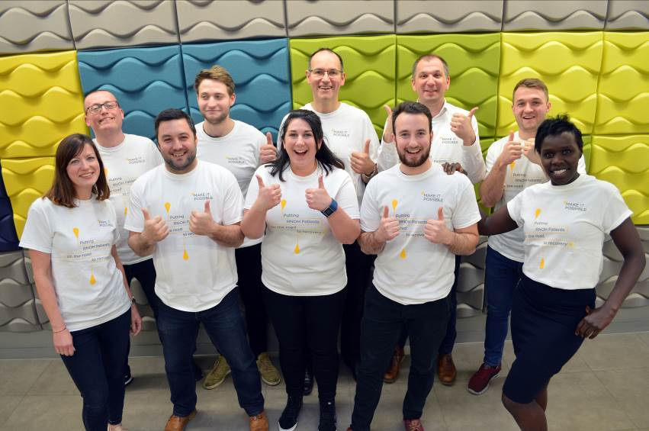

The Buttercup Walk
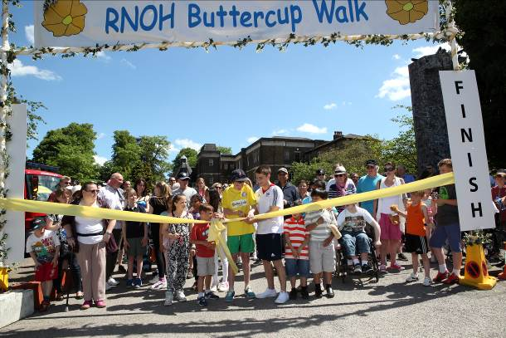
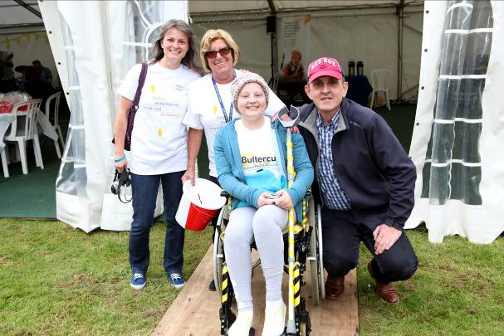
Alternatively, you and your staff could participate in our annual Buttercup Walk – our biggest fundraising event of the year, or even organise your own! We need volunteers to man stalls, help us set up, sell raffle tickets, direct walkers – anything you can think of! It’s a lovely fun-filled family event and a great way to get involved with the Charity!

Sponsorship
We need your help to design and construct a truly world-class, innovative healthcare environment that will bring real improvements in the quality of our care and transform the lives of our patients. Sponsorship is an important way of getting involved in The RNOH Charity, letting us put more of the money our supporters raise back into the hospital and services that we provide, and giving you recognition on our social media, website, and any local press we’re featured in.
There are plenty of ways to get involved, from sponsoring part of our Buttercup Walk, to getting involved in our brand new crowdfunding platform, www.makeitpossible.org.uk. For more information about sponsorship opportunities just get in touch.
Company donations
The RNOH Charity appreciates any and all contributions from businesses of any size. There are a number of ways that we can acknowledge a sizable donation – please just get in touch to find out more about the projects that we are currently looking to fund and for information about the different types of Charity acknowledgement on offer.
Matched giving
Your business can support your employees’ fundraising activities by offering a matched giving scheme, where you match, or double, any funds raised by your employees for a charitable cause.
If you see a particularly exciting project featured on our crowdfunding platform, there is also the option to offer match funding opportunities for donations received e.g. you could match fund the first £500 worth of pledges towards that campaign.
Payroll Giving
​Payroll giving is one of the easiest ways to make a regular donation to The RNOH Charity. Donations are made straight from your salary, before tax is taken and is an efficient and hassle-free way to contribute to vital research, equipment, and facilities at the RNOH.
Gifts in Kind:
The RNOH Charity is always happy to accept donations towards our children’s ward and waiting areas. Please get in touch with the team for a full list of items that the children’s ward is in need of.
We would be grateful for high-quality items to raffle for our Buttercup Walk, or for our Christmas raffle. Raffles give the Charity an opportunity to give something back to our supporters in return for their generosity throughout the year and we appreciate every contribution that we receive towards them.

